
Company
Logotype

Cone Beam Computed Tomography- Report



Porur Dental X-rays & CBCT

Patient Name : Ms. Aishwarya | Date of Report : 30.08.2024
Age/ Gender : 25 years/ Female | Region of Interest : CBCT Sectional Maxilla
Referring doctor: Dr. Selva Ganesh | Indication : Assessment of 27
Clinical Notes: Nil
PATIENT INFORMATION

CBCT- Sectional Maxilla provided
CBCT – IMAGE DETAILS

RADIOGRAPHIC INTERPRETATION

- In relation to 26, 27 presence of hyperdense crown structure with hyperdense restorative material involving the crown and extending into the mesio-buccal, disto- buccal and palatal root canal upto the apical third is evident.
- In relation to the periapical aspect of 27 palatal root, presence of mild area of hypodensity, measuring 2.7 x 3.43 x 1.48 mm in dimension with diffuse margins is evident.
- The alveolar bone in relation to the maxillary alveolar ridge is present with normal trabecular pattern.

RADIOGRAPHIC IMPRESSION

- Root canal treated tooth: 27 with periapical pathology.
- Root canal treated tooth: 26

Kindly correlate with clinical findings


IMAGES FOR REFERENCE

RECONSTRUCTED PANORAMIC VIEW

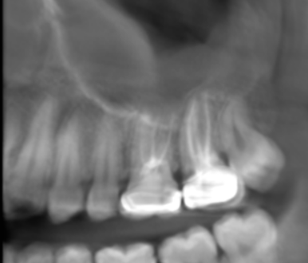

3-DIMENSIONAL VIEW

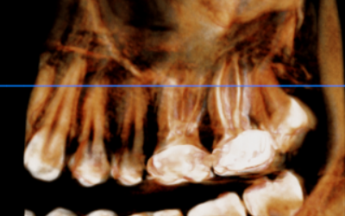

CROSS SECTIONAL VIEW

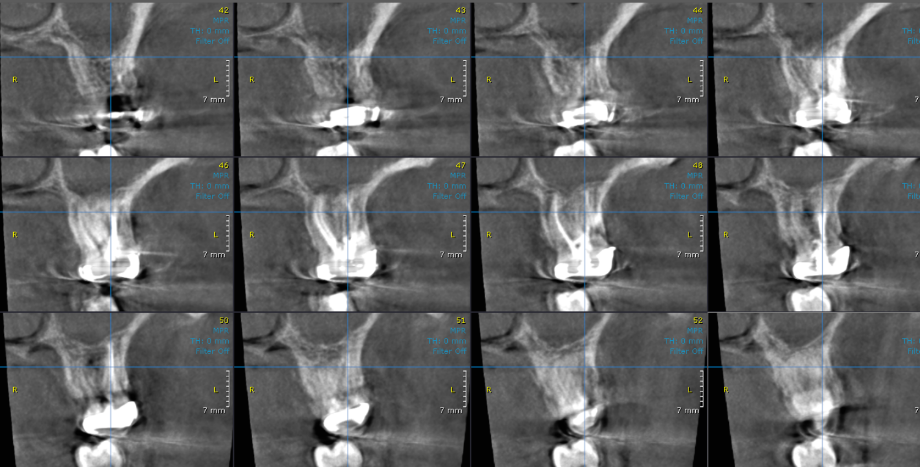

MULTIPLANAR VIEW
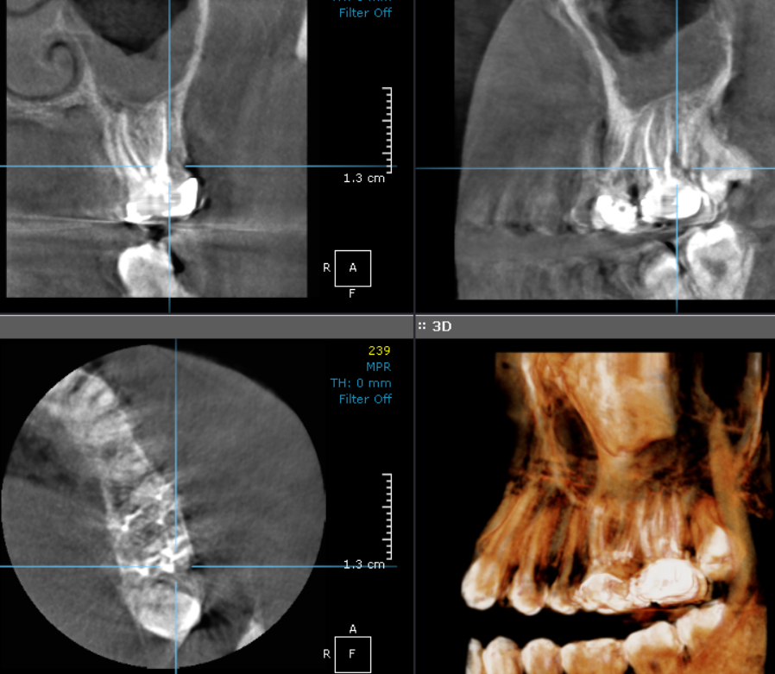

**** End of report ****

